**WINDOWS: COMPILE DISPLACE FROM THE DISPLACE SDK**

Set up CLion in Menu>File> settings

For amd64 architecture because we are 64bits!

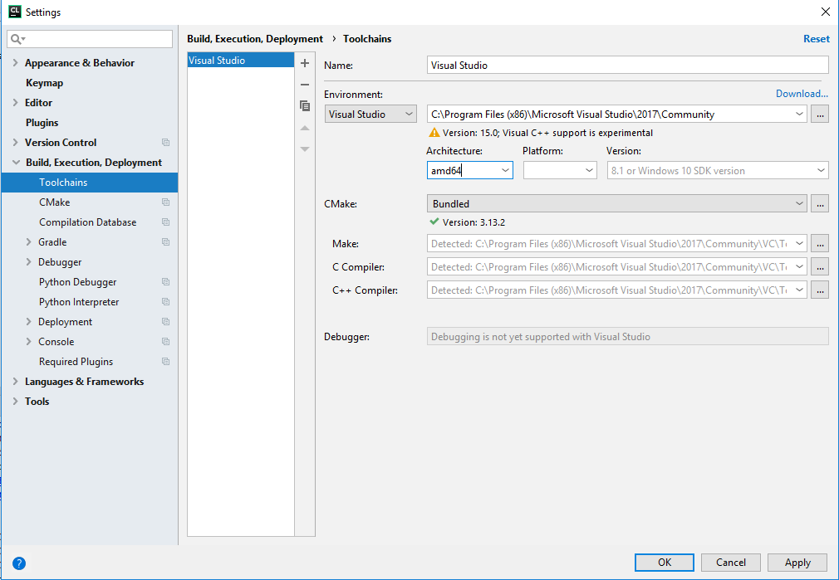

Install CMake on your computer

Unzip the sdk vcpkg-export-20181211-212458.7z (build with <https://docs.microsoft.com/en-us/cpp/vcpkg?view=vs-2017>, see Building.md, you will found the sdk on the DISPLACE_release\WindowsSupport on google drive <https://drive.google.com/drive/folders/0B7xTkBu0-QI5bnIxS3c4dy0tSUU> ) in DISPLACE_GUI install and rename the folder for e.g. displacesdk

cd <your sdk position>

Install Python 3 <https://www.ics.uci.edu/~pattis/common/handouts/pythoneclipsejava/python.html>

and run the python >=3.7.0 script for a fix on hardcoded absolute paths with

python.exe <your-displace-position>/tools/vcpkg-fixup.py

Open the DISPLACE project e.g. in QtCreator or CLion with the CMakeList.txt file

Configure CMake by adding a arg variable, for example:

CMAKE_TOOLCHAIN_FILE=C:\Users\fbas\Documents\GitHub\DISPLACE_GUI\install\displacesdk\scripts\buildsystems\vcpkg.cmake

In QtCreator:

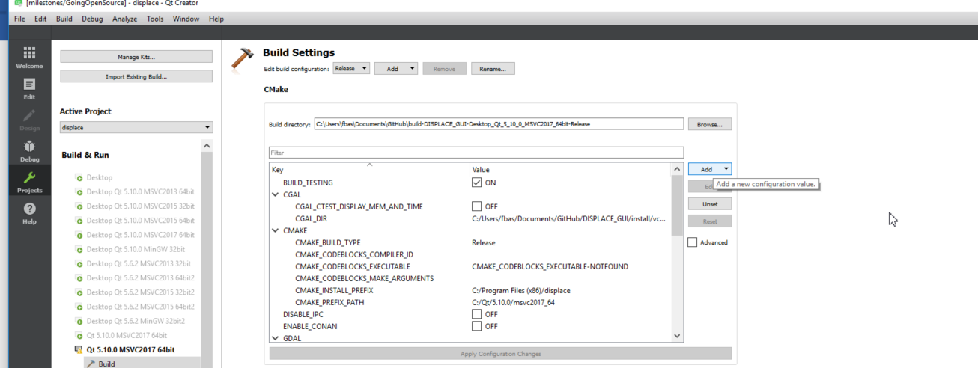

In CLion:

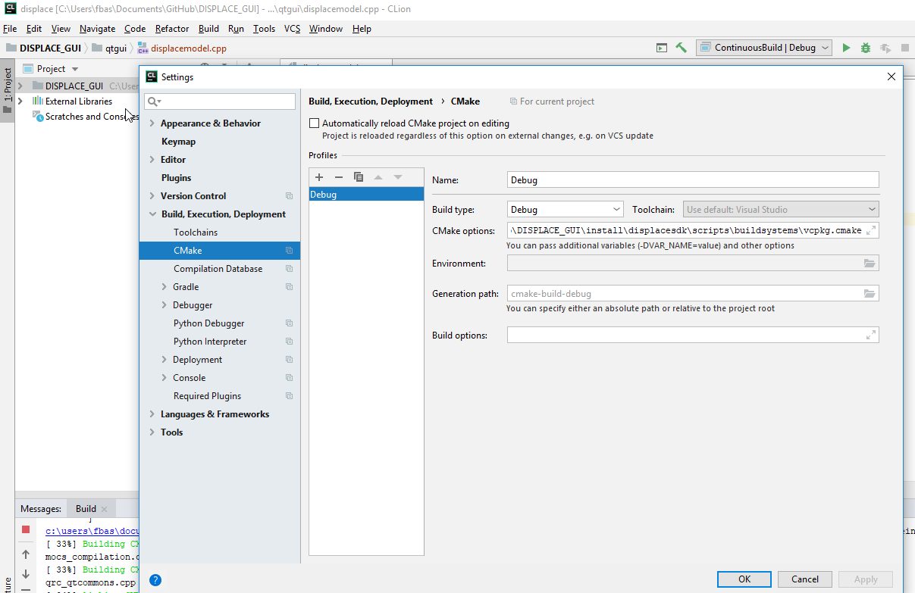

Clear or reset cache and re-run CMake

Compile DISPLACE_GUI

Add C:\Users\fbas\Documents\GitHub\DISPLACE_GUI\install\displacesdk\installed\x64-windows\bin and \lib to PATH

Set the Run on displacegui and run!

(If CLion, Run displace first to Build it with CMake…..)

*NOTE: If the SDK is having the Qt already included then it will not work with QtCreator, because QtCreator get confused*

*Better to use a SDK not including Qt…..*

*In this case then setting an extra arg will be required for CMake to find a Qt:*

*CMAKE_PREFIX_PATH=c:\Qt\5.12.0\msvc_64*